Health and hygiene are an important aspect of human life. But due to unfavourable circumstances, we are prone to falling sick or suffering from health problems. People living in remote areas severely lack access to good medical facilities, either they are short staffed or have insufficient equipment and resources. These facilities provide low-grade health care to patients and are mostly unsanitary. Also, one of the major issues is the population, the total number of health care centres available are far less than what is actually required, due to which these medical facilities are overcrowded and patients have to wait for hours for their turn.  
Therefore, since long a need for some digital application which would be helpful to the users (patients in the context of our project) to get a diagnosis of their medical problems is felt. This system takes the user (i.e. A patient in this case) inputs as symptoms and diagnoses the corresponding disease. Thus it learns from those symptoms to diagnose the corresponding disease to the best of its learning ability.  
Medical tests such as X-Rays are important for identifying important conditions pertaining to our body. Thus, to incorporate it, we are also providing an additional feature for the users to upload a chest X-Ray image as an input to this system and to diagnose and determine whether the lungs are in a healthy condition or not. Common conditions related to the lungs will be identified.  
So this project is focused towards medical diagnosis, and therapeutics. The target beneficiary for this project would be poor and needy people and those deprived of proper medical facilities.

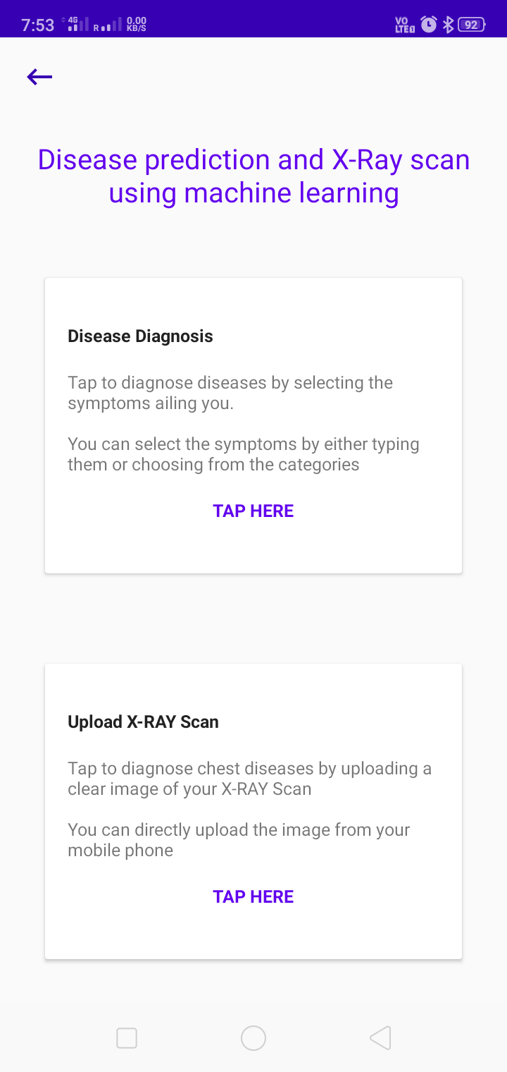 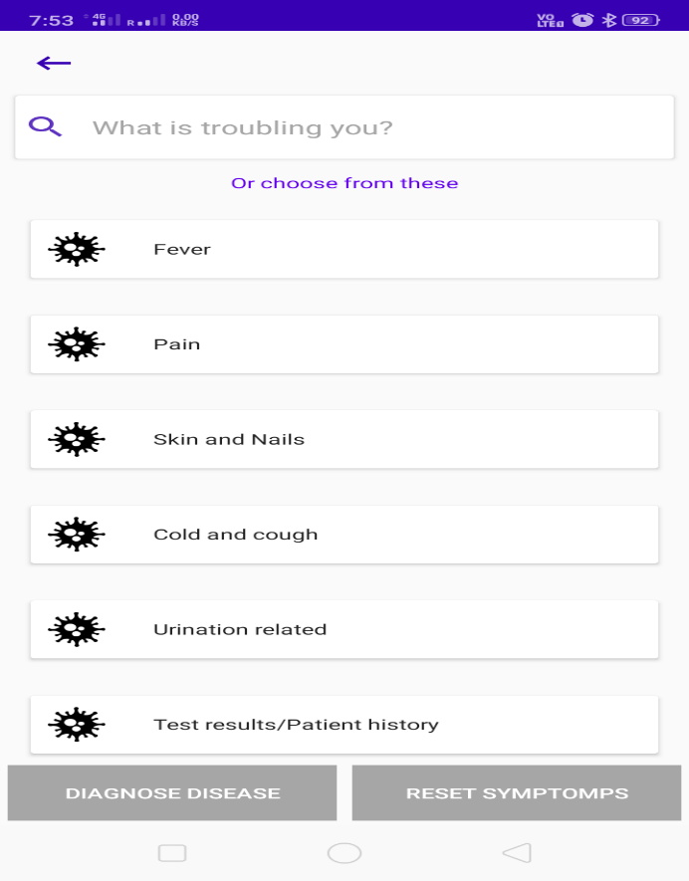

Home page showing two distinct functionalities of our app.

“Disease Diagnosis” screen showing various groupings from which user can select his/her symptom.

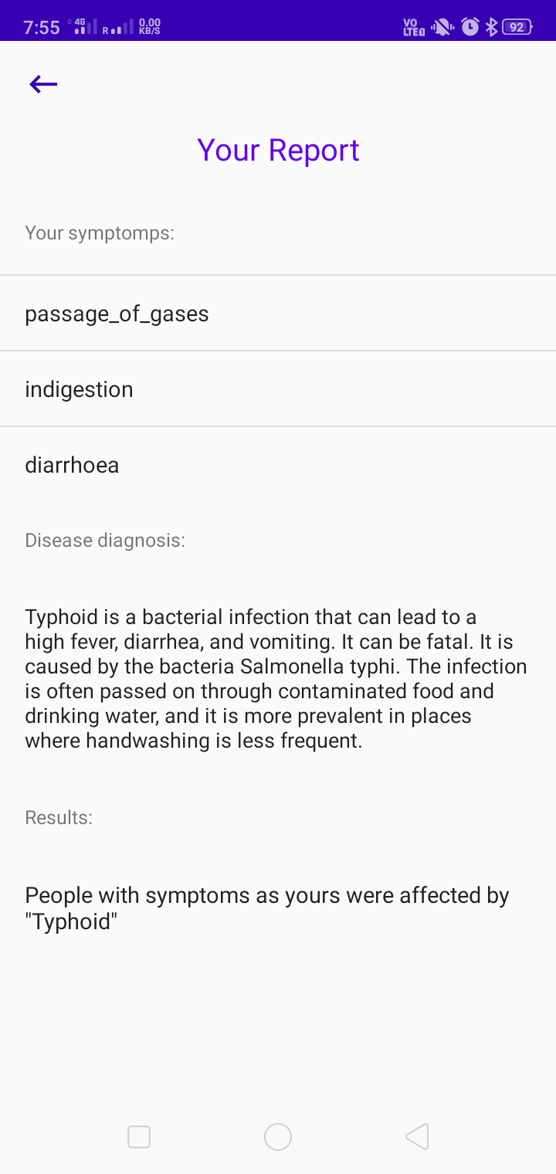 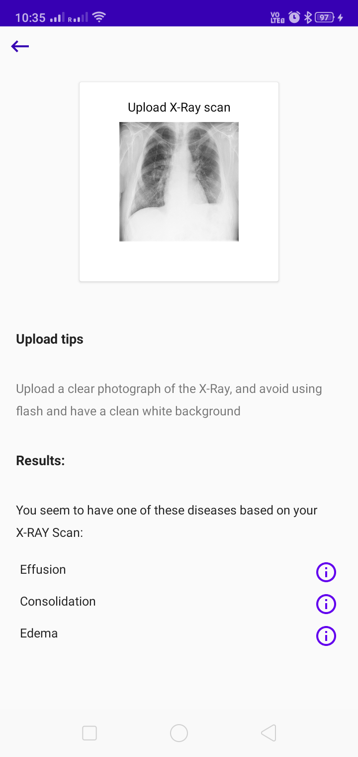

Final generated report showing diagnosed lung condition that the user could be suffering from, corresponding to the selected Chest X-Ray image.

Final generated report showing diagnosed disease that the user could be suffering from, corresponding to the selected symptoms.